Year 1 Spanish 2026 – 2027
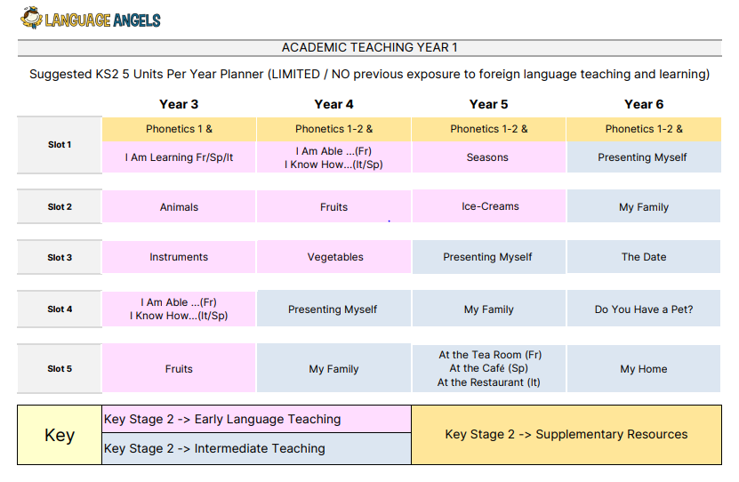

Year 2 2027 – 2028
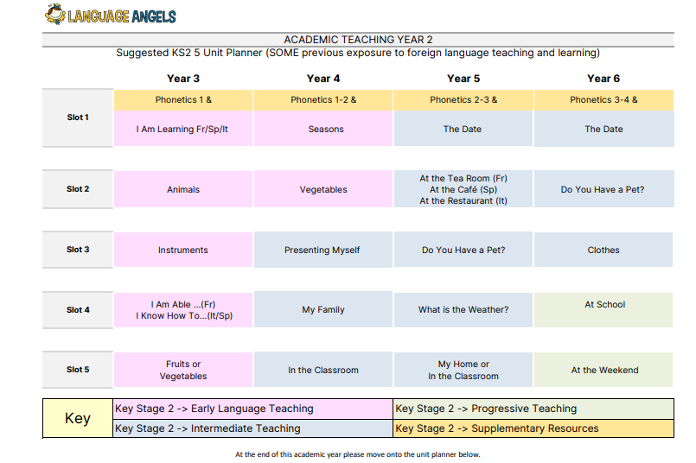

Year 3 2028 – 2029


