Fun at the Seaside!
Summer 2 Foundation Stage Home Learning Menu

Weekly Activities
Reading – Please read/share a story with your child at least 4 times a week, and record this in their reading diary. Remember 4 reads= 4 dojo points!
Maths – Daily counting forwards/backwards to and from 10/20. Counting out 5 or more objects accurately.
Home Learning
Home Learning can be presented in a variety of ways. From writing to pictures of practical work, creative pieces and dictated sentences written by parents are all fantastic. Please ask your child’s class teacher if you are unsure. Some suggested ideas are below.
Home learning can be emailed to natalie.lloyd@brookfieldjunioracademy.org
Draw the things you would need to take to the beach. Challenge: Can you write the initial sound of the picture, e.g ‘b’ for bucket  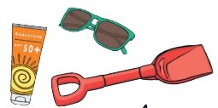 | Imagine you have found a magic shell at the seaside. You can have one wish. Draw a picture or write about what your wish would be!  
Can you make a boat from any empty containers you have got at home? Does it float? How many 10p pieces can it carry before it sinks?  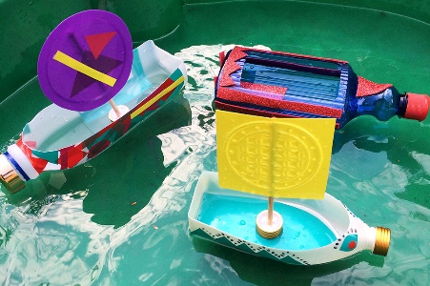 | Draw or paint a picture of an animal you might find in the ocean.  
Have a go at some seaside themed baking!   | Practice writing your name  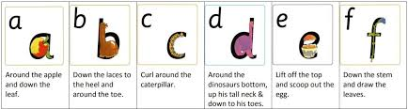  Practice your oral blending skills such as h.a.t- hat  

