Fun at the Seaside!
Summer 2 Foundation Stage Home Learning Menu

Weekly Activities
Reading – Your child reading 4 or more times a week using their phonics books or a reading for pleasure book. Parents will need to sign or comment in their child’s planner.
Maths – Daily counting forwards/backwards to and from 10/20. Identifying one more/less to 10 and Number bonds to 10/20
Weekly Home Learning
Home Learning can be presented in a variety of ways. From writing to pictures of practical work, creative pieces and dictated sentences written by parents will be accepted. Please ask your child’s class teacher if you are unsure. The weekly homework tasks are below. Please choose one piece to complete weekly.
Write a list of things you would need to take to the beach.  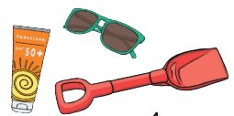 | Imagine you have found a magic shell at the seaside. You can have one wish. Draw a picture or write about what your wish would be!  
Can you make a boat from any empty containers you have got at home? Does it float? How many 10p pieces can it carry before it sinks?  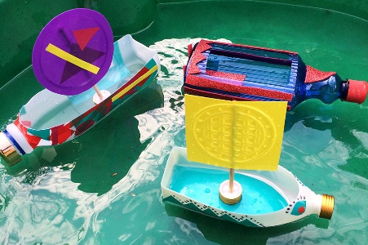 | Draw a picture of an animal you might find in the ocean.  
Have a go at some seaside themed baking!   | Please see website for information and activities to support your child  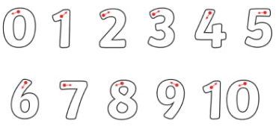  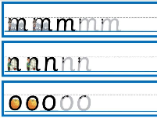  Ask your child’s class teacher for extra hand writing and letter and number formation sheets.

