Ticket to Ride!
Summer 1 Foundation Stage Home Learning Menu

Weekly Activities
Reading –Each week your child will also be sent home a "reading for pleasure" book to share at home. We ask that you record at least four times a week in your child's reading record (can also be any book of choice).
Maths – Daily counting forwards/backwards to and from 10/20. Using fingers to represent numbers. Singing counting songs and rhymes.
Home Learning menu- Please choose one or more
Home Learning can be presented in a variety of ways. From writing to pictures of practical work, creative pieces and dictated sentences written by parents will be accepted. Please ask your child’s class teacher if you are unsure. Homework can be emailed to natalie.lloyd@brookfieldjunioracademy.org
Think about a journey you often make. Can you draw a simple map showing some of the things you see on the journey?  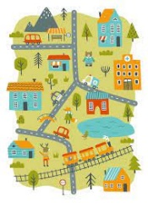 | Make up a story with a grown-up about an adventure you could have in a hot-air balloon.  
Can you make a model of your favourite type of transport? You could use empty cardboard boxes or building bricks. What model will you make? You could make a car, bus, train or hot-air balloon!  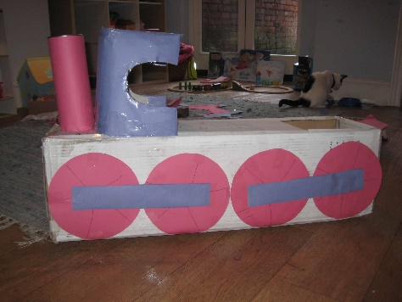 | Draw or paint a picture of a vehicle  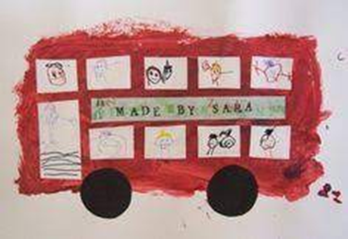
Have a go at making some transport themed baking  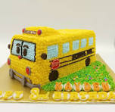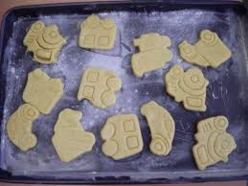 | Practice writing your name and other letter sounds, maybe even numbers too.  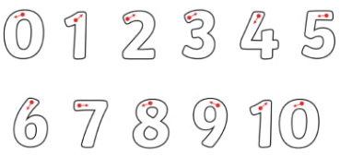  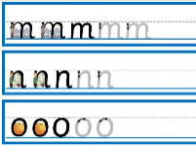  Ask your child’s class teach or see the schools website for any further information on supporting your child

