Ticket to Ride!
Summer 1 Foundation Stage Home Learning Menu

Weekly Activities
Reading – Your child reading 4 or more times a week using their phonics books or a reading for pleasure book. Parents will need to sign or comment in their child’s planner.
Maths – Daily counting forwards/backwards to and from 10/20. Identifying one more/less to 10 and Number bonds to 10/20
Weekly Home Learning
Home Learning can be presented in a variety of ways. From writing to pictures of practical work, creative pieces and dictated sentences written by parents will be accepted. Please ask your child’s class teacher if you are unsure. The weekly homework tasks are below. Please choose one piece to complete weekly.
Think about a journey you often make. Can you draw a simple map showing some of the things you see on the journey?  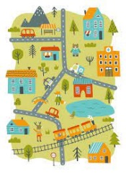 | Make up a story with a grown-up about an adventure you could have in a hot-air balloon.  
Can you make a model of your favourite type of transport? You could use empty cardboard boxes or building bricks. What model will you make? You could make a car, bus, train or hot-air balloon!  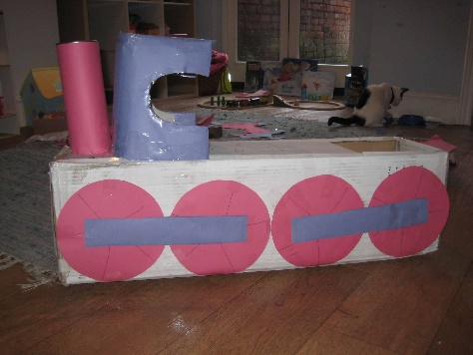 | Draw or paint a picture of a vehicle  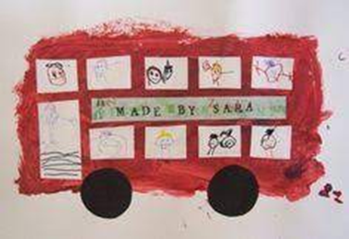
Have a go at making some transport themed baking! Mrs Hartshorn and Miss Tilbrook love baking so would be very impressed to see some of your tasty creations!!  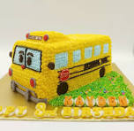 | Please see website for information and activities to support your child  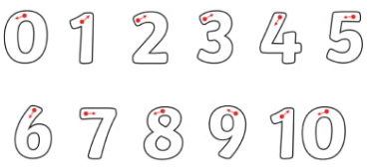  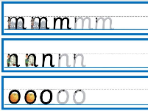  Ask your child’s class teach for extra hand writing and letter and number formation sheets.

