What a Wonderful World!
Spring 2 Foundation Stage Home Learning Menu

Weekly Activities
Reading – Your child reading 4 or more times a week using their phonics books and/or a reading for pleasure book. Parents will need to sign or comment in their child’s planner.
Weekly Home Learning
Home Learning can be presented in a variety of ways. From writing to pictures of practical work, creative pieces and dictated sentences written by parents will be accepted. Please ask your child’s class teacher if you are unsure. The weekly homework tasks are below. Please choose one piece to complete weekly.
Try making a model of a flower. You could use playdough, paper or card, construction toys, empty cardboard tubes and boxes or plastic tubs and pots. Think about how you could make the stem, the flower and the leaves. We would love to see any models you make!  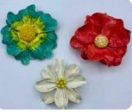 | Can you build a den outdoors? You could role-play in there read in there? Take some photographs of your time in there you could get an adult to write about how you made your den or you could write instructions. You could get a adult to support you in writing about how you spent your time in there or you could write some sentences independently.  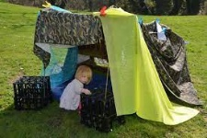
Try growing some plants or flowers at home. You could try planting some seeds in a pot or in your garden. Remember to give your seeds some water and put them somewhere sunny. Cress seeds grow quite quickly or you could try planting some flowers  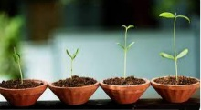 | Draw or paint an Easter picture - you could draw some Easter eggs, flowers, chicks or even the Easter bunny!  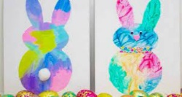
People often celebrate Easter by eating hot cross buns, chocolate and cakes. Enjoy making some sweet treats to share with your family and friends. We would love to see a photo or picture of any treats you make.   | At Spring time lots of flowers start growing in the ground and on trees. Go for a walk around a park or garden and see what flowers and plants you can see growing.  You could take some photos or draw some pictures of the things you see. You could even write some sentences about what you can see.  

