Paws, Claws & Whiskers
Spring 2 Home Learning

Weekly Activities
Reading – Your child reading 4 or more times a week using their phonics books or a reading for pleasure book. Parents will need to sign or comment in their child’s planner..
Maths – Daily counting forwards/backwards to and from 20. Identifying one more/less to 10 Number bonds of 5 and 10.
Activity 1 | Activity 2
Make a party hat for our ‘Tiger who came to Tea’ Tea party!  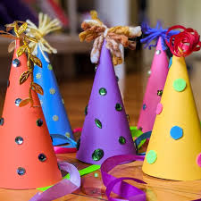 | Draw or paint a picture of your favourite animal.  You could even write about it – Remember to use finger spaces, fred fingers, full stops and capital letters if you are F2.  If you are F1 your adult could write what you say.  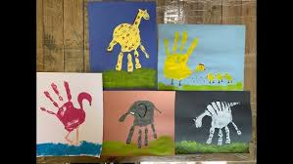
Activity 3 | Activity 4
Learn about chicks hatching with Auntie Mabel and Pippin. https:// www.youtube.com/ watch?v=swQujfPhXd0  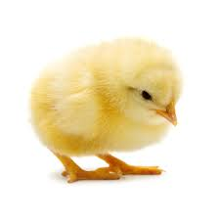  Make scrambled eggs to eat. How does the egg change as you cook it? | Create your own art around butterflies.  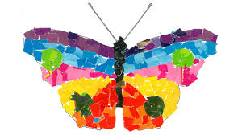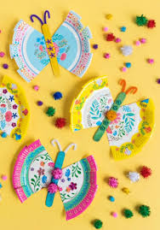  Begin a scrap book about the life cycle of our chicks or caterpillars.
Activity 5
Visit and take photographs to share with the class a visit to a zoo or a farm. Remember to present the photographs to your class and remember what you saw and did on your visit.
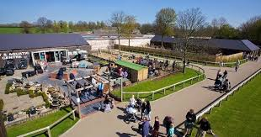
You could even write your own recount
You could draw or paint or draw your own pictures
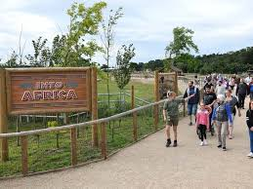
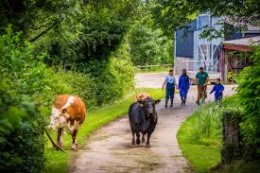

.

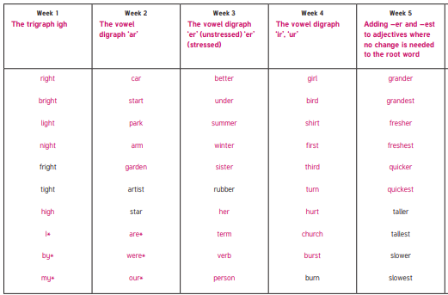

Year 1/2 Spring 1 Spellings

