TERRIFIC TALES!
Foundation Stage Autumn 2 Home Learning

Weekly Activities
Reading – Your child reading 4 or more times a week using their phonics books or a reading for pleasure book. Parents will need to sign or comment in their child’s Reading record.
Maths – Daily counting forwards/backwards to and from 20.
Please choose from the following activities – you can do all of them or as many as you can manage. Space them out over the half term to suit you and remember to share to earn 4 Dojos per activity.
Activity 1 | Activity 2
Create your own Halloween and or Christmas themed baking and share photographs with the class.  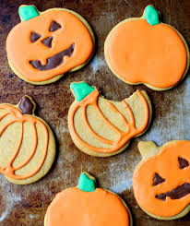 | Draw a picture of you and your family celebrating a special occasion. This could be a birthday, Wedding, Halloween, Diwali, Bonfire night, Eid, Christmas Time.  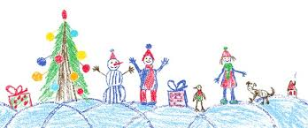
Activity 3 | Activity 4
Can you make your own little house from junk box modelling for the 3 little pigs.  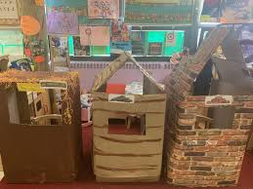 | Discuss or write down with adult support 3 words that rhyme with:  - Pig  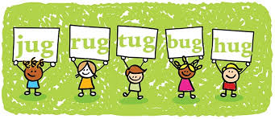  - Bear  - Tree
Activity 5

Can you make a Christmas decoration for our Christmas Tree at school?

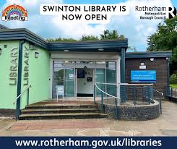
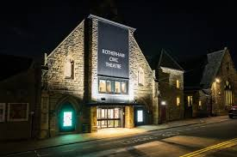
Other activities:
Can you visit a library and share a traditional tale with your adult?
Can you visit a pantomime and share this experience with your teacher?

.

Year 1/2 Spring 1 Spellings

