
Brookfield Junior Academy Fluency Long Term Plan 2025

What is Fluency in mathematics?
What is fluency in mathematics? Fluency in mathematics is about developing number sense and being able to find the most appropriate method for the task at hand; to be able to apply a skill to multiple contexts. The National Curriculum states that pupils should become fluent in the fundamentals of mathematics through varied and frequent practice. Until children know key mathematical facts and can recall them efficiently, they will not be able to delve deeper into their learning.

Fluency/Arithmetic sessions
Our fluency/arithmetic sessions will be fun, varied and fast paced. We want ALL our children to be ‘mathematically active’ for the whole session. In our sessions we need to make sure that we are teaching the specific facts set out in the tables below. Each year group has specific facts to focus on in each half term.
Resources
We have a range of resources to use in our sessions including:
• Rapid Recall Boards/whiteboards
- Number fans
• Counting sticks/ circles
• Times Table Rock Stars/ Times tables check
• Interactive games – Primary Games, Hit the Button, topmarks
• Concrete equipment – 10’s frames, place value charts, two sided-counters, cubes etc.
Guidance and principles
We need to use a variety of concrete manipulatives to introduce facts for example: counters, straws, base 10 etc. We also need to use pictorial representations so that the children can visualise ‘numbers’ including: 10’s frames These should be used to embed the concepts of addition and subtraction for example, number bonds - children can use different coloured counters to show different ways to make numbers. Numerals should be introduced alongside these images.
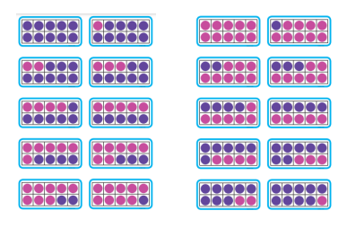
Part-part whole model and bar model These representations should be used interchangeably and also alongside writing straightforward number sentences.

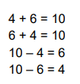
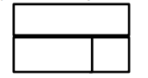
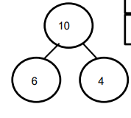
All classes should:
- Introduce the basic facts and teach strategies for calculating and remembering them.
- Use a variety of models and images so that the facts are not just abstract.
- Allow time for children to practice and memorise facts.
- Make parents aware of the half termly focus and facts their children are expected to learn.

Assessment
At the end of a term assess the children’s attainment against fluency focus.
• Working below – unable to recall any facts or use any strategies
• Working towards – can recall most basic / root facts
• Working at – can recall basic facts, related number facts and missing number problems
• Working at greater depth – can use facts fluently
Any children deemed working below or towards the standard in relation to the fluency objective should be targeted through intervention.


