
Wednesday 4th June 2025

Uniform Clarification for FS1 to Year 6 for September 2025

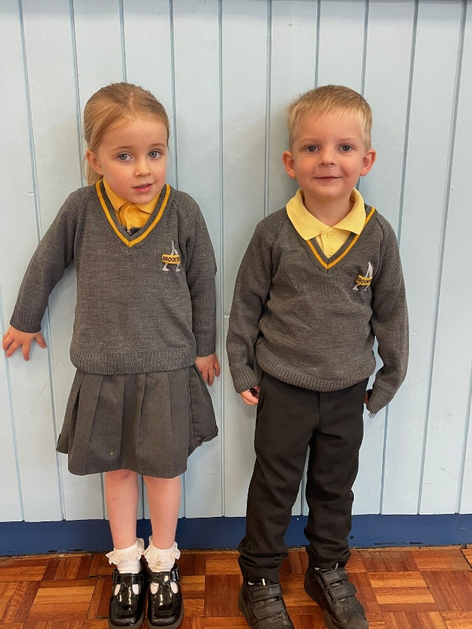
Grey V-neck jumper with logo from Pinders, or cardigan with or without logo. From Sept 2026 no logos will be required.
Yellow/gold polo shirt. No white shirt. (Pinders currently have a deal on gold polo shirts, £10 for 5).
Yellow gingham dress in summer term
No blazer or tie
Grey or black skirt, shorts or trousers
Black shoes

PE Kit Expectations:
Indoor PE | Outdoor PE
- Black shorts (unbranded)  - White t-shirt (unbranded) | - Trainers  - Black jogging bottoms (unbranded)  - Black long sleeve top / hoodie (unbranded)

