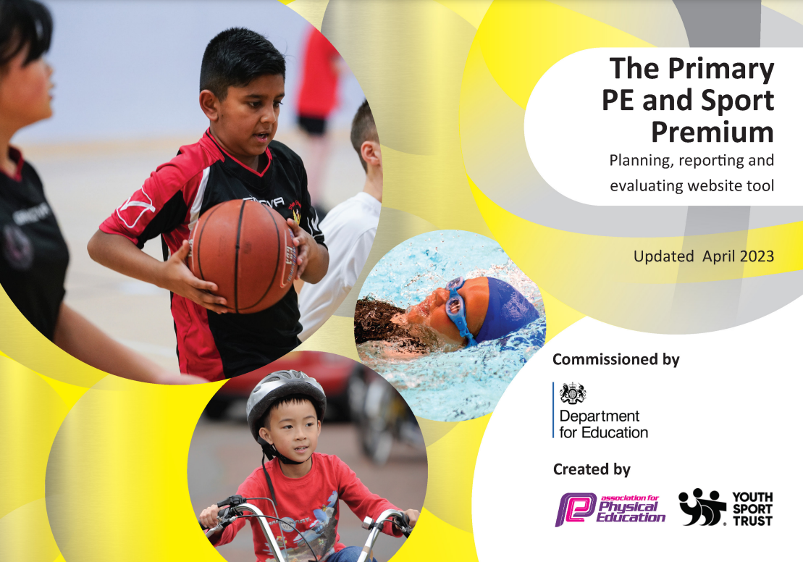
ACET School: Brookfield Junior Academy

PE Lead: Beth Handisides

Principal: Daisy Dunning


It is important that your grant is used effectively and based on school need. The Education Inspection Framework makes clear there will be a focus on ‘whether leaders and those responsible for governors all understand their respective roles and perform these in a way that enhances the effectiveness of the school’.

Under the Quality of Education Ofsted inspectors consider:
Intent - Curriculum design, coverage and appropriateness
Implementation - Curriculum delivery, Teaching (pedagogy) and Assessment
Impact - Attainment and progress

To assist schools with common transferable language this template has been developed to utilise the same three headings which should make your plans easily transferable between working documents.

Schools must use the funding to make additional and sustainable improvements to the quality of Physical Education, School Sport and Physical Activity (PESSPA) they offer. This means that you should use the Primary PE and sport premium to:

- Develop or add to the PESSPA activities that your school already offer
- Build capacity and capability within the school to ensure that improvements made now will benefit pupils joining the school in future years
- The Primary PE and sport premium should not be used to fund capital spend projects; the school’s budget should fund these.

Pleasevisitgov.ukfortherevisedDfEguidanceincludingthe5keyindicatorsacrosswhichschoolsshoulddemonstrate animprovement.Thisdocumentwillhelpyoutoreviewyourprovisionandtoreportyourspend.DfEencouragesschools to use this template as an effective way of meeting the reporting requirements of the Primary PE and sport premium.

We recommend you start by reflecting on the impact of current provision and reviewing the previous spend.

Schools are required to publish details of how they spend this funding, including any under-spend from 2019/2020, as well as on the impact it has on pupils’ PE and sport participation and attainment. All funding must be spent by 31st July 2022.

We recommend regularly updating the table and publishing it on your website throughout the year. This evidences your ongoing self-evaluation of how you are using the funding to secure maximum, sustainable impact. Final copy must be posted on your website by the end of the academic year and no later than the 31st July 2021. To see an example of how to complete the table please click HERE.


Created by: Supported by

Swimming Data
Please report on your Swimming Data below.

Meeting national curriculum requirements for swimming and water safety.  N.B. Complete this section to your best ability. For example, you might have practised safe self-rescue techniques on dry land which you can then transfer to the pool when school swimming restarts.  Due to exceptional circumstances priority should be given to ensuring that pupils can perform safe self-rescue even if they do not fully meet the first two requirements of the NC programme of study | 23%
What percentage of your current Year 6 cohort swim competently, confidently and proficiently over a distance of at least 25 metres?  N.B. Even though your pupils may swim in another year please report on their attainment on leaving primary school at the end of the summer term 2021.  Please see note above | 14%
What percentage of your current Year 6 cohort use a range of strokes effectively [for example, front crawl, backstroke and breaststroke]?  Please see note above | 80%
What percentage of your current Year 6 cohort perform safe self-rescue in different water-based situations? | 89%
Schools can choose to use the Primary PE and sport premium to provide additional provision for swimming but this must be for activity over and above the national curriculum requirements. Have you used it in this way? | Yes

Action Plan and Budget Tracking
Capture your intended annual spend against the 5 key indicators. Clarify the success criteria and evidence of impact that you intend to measure to evaluate for pupils today and for the future.

Academic Year: 2022/23 | Total fund allocated: £18,050 | Date Updated: 3rd May 2023
Key indicator 1: The engagement of all pupils in regular physical activity – Chief Medical Officers guidelines recommend that primary school pupils undertake at least 30 minutes of physical activity a day in school |  |  |  | Percentage of total allocation:
 |  |  |  | 41%
Intent | Implementation |  | Impact
Your school focus should be clear what you want the pupils to know and be able to do and about  what they need to learn and to  consolidate through practice: | Make sure your actions to achieve are linked to your intentions: | Funding allocated: | Evidence of impact: what do pupils now know and what can they now do? What has changed?: | Sustainability and suggested next steps:
Healthy Breakfast for all schools  Contribution to the National Breakfast Scheme (bagels/cereals)  Swimming including transport  Swimming lessons extension. Increase the funded 12 weeks NC swimming session with an extra 12 weeks for our children at BJA. To achieve a higher number of children passing and achieving National Curriculum standard.  PE kit  Spare kit for PP children, taking part in PE and being inclusive to all.  Last academic year bigger sizes purchased. This year EYFS/KS1 are the children who are struggling to provide a PE kit of their own consistently, therefore smaller sizes purchased for the younger children in the school.  Play time equipment  Replenish all playground equipment to have separate from PE equipment, boxed and stored safely for each playground at break and lunch time. Playground leaders to be responsible.  EYFS provision development  Helping with physical, fine and gross motor development. Purchasing climbing equipment, water trays and gardening equipment.  SEND equipment  SEND Communication in Print. After discussion with our SENDCO/principal and EYFS lead, this area was highlighted as a need for our children/staff at BJA. This is to help our children with SEND, using this on their now and next boards, individual timetables and scaffolds. | Purchasing of bagels or toast for children to eat every morning at school to allow them to have the opportunity of a healthy breakfast at the start of each day.  Curriculum 12 weeks offered plus an extra 12 weeks offered for the same group of children. This is to try and improve overall swimming data for the end of year 6, for children to reach NC level.  PE kits being boxed up for each key stage (EYFS/KS1/KS2), forgot kits or children who are PP/disadvantaged. Save at school for these children, storage in equipment 2 cupboard or classroom stock cupboards.  We now have playground/sports leaders in year 6 who run and lead activities at lunch times to all of our children. Each playground used at dinner time has their own specific box of equipment with an audit label. This is to ensure all equipment is put back into the box at the end of the play time.  Outdoor provision in EYFS has been noted as an area to build on. Therefore, some of our SP funds have been used for equipment in the outdoor area, for children to develop their skills when in provision outside (phase 1 phonics and assessments).  After working closely with the SENDCO AG and EYFS lead LC, all members of staff have received a login for communication in print and have full access to the resources. CPD in a staff meeting has been delivered by EYFS lead/PE lead to show how to use this tool for children in their classes. Whether this may be on individual timetables or now and next boards. | £800  £5500  £200  £0  (Children’s University Bid £250 voucher)  £550  £400 | All children have access to a healthy breakfast at the start of the school day. Children seem to be more focused during the whole school day as a result of having a healthy breakfast at school with their friends.  Ensure that all our children in the class we take swimming, can all swim to a standard that will ensure that they are safe around open water and if possible, pass the NC standard. Children also access the local swimming pool for own swimming sessions either for lessons or family sessions.  All children at BJA now have a PE kit, from FS1 to Year 6, that they wear in their PE lesson. All children are dressed the same in the ACET PE kit, black and gold rugby top or plain white/yellow and black shorts, demonstrating high expectations expected in PE and role models for each other.  Children are leading an active play time gaining more minutes of being physically active a day. Less behaviour issues due to children being engaged in games by role models in year 6 and dinner staff.  Children are exploring new ways to play in the outdoor provision, whilst at the same time are learning and developing new skills.  A lot of our children mixed across the school from FS1 to Year 6 have positively responded to communication in print. The use of their now and next cards have shown to keep a routine and gave clear understanding of their instructions of what the staff expect now and next. | Continued purchasing of bagels in order for children to have to access to a healthy breakfast at school if they wish.  To continue to offer an extended swimming provision for our children at Brookfield, due to children not accessing swimming outside of school. The extra 12 weeks have shown to have increased the number of children passing and achieving NC from data, comparing the first 12 weeks, to the last 12 weeks.  Maintain next year and develop a spare shoes/pumps/trainers cupboard, as this is our new arising issue to PE kit for outdoor lessons.  Playground leaders to continue in the next academic year alongside the sports leadership training. Regular meetings to discuss plans to further develop.  Continue to utilise equipment when in outdoor provision and phonics groups, small intervention groups. Play leaders to monitor the F1 area at lunch time for the equipment to be used.  All classes to maintain this method for routine of the day for all children in their classes, become familiar with other children who have specific now and next boards for transition.
Key indicator 2: The profile of PESSPA being raised across the school as a tool for whole school improvement |  |  |  | Percentage of total allocation:
 |  |  |  | 25%
Intent | Implementation |  | Impact
Your school focus should be clear what you want the pupils to know and be able to do and about  what they need to learn and to  consolidate through practice: | Make sure your actions to achieve are linked to your intentions: | Funding allocated: | Evidence of impact: what do pupils now know and what can they now do? What has changed?: | Sustainability and suggested next steps:
Cross curricular workshops  Broaden the curriculum through active workshops that link with curriculum topics/cultural difference. Kids Love Yoga, Sports for Schools, Primary School Workshops. Expose the pupils to traditional and non-traditional sports and health enhancing activities. Through high quality PE lessons and workshops provided by coaches.  - Yoga Workshop (World Health Day)  - First Aid Junior Affiliation KS2  - Kings Coronation Workshop  - Football Freestyler  - Dancethon – Dance Day  PE specific equipment  - Footballs and bibs  - Rounders package  - Tennis balls  Sports council voice and pupil voice feedback  Netball post protectors  Purchased for safety when using the nets in PE lessons and during afterschool clubs.  Sports Leadership affiliation  This gives children the opportunity to train to become play/lunch time leaders.  Rotherham United package  Rotherham United Joy of moving schools package 22-23  SMSAs leading active lunchtimes  Training given and wages part funded from this. | This academic year we’ve had; a yoga/mindfulness workshop, Kings Coronation dance workshop, football freestyler workshop, first aid/mental health workshop which gave KS2 children the Junior Affiliation Award, Ghana dance day exploring different cultures, active travel parking pledge sessions, bike ability, scooter and cycle skills. These workshops are intended to create cross curricular links and explore other areas of the wider community with real life events and topics. These workshops give our children different opportunities within their personal development, alongside physical activity.  Sports council meetings and playground leader meetings often discuss equipment for PE lessons rather than just for playtimes. During a recent meeting and pupil voice questionnaire, we asked what sports are their favourite in school. Football and rounders are two of the most popular.  To safely use the netball nets in PE lessons, lunch times and afterschool clubs.  Children are trained and put on a rota in order to help deliver mini games/activities at lunch and play times to encourage people in active play.  Increasing children’s awareness of equality and diversity in sports. Increasing knowledge further to enhance the importance of a healthy active lifestyle.  - 6 weeks Year 5/6 healthy active lifestyle program  - RUFC player visit, assembly and meet and greet/signing opportunity  - Miller Bear visit  - Summer Fayre stall  - Sports day involvement  - Inflatable day – penalty shootout and blow up pitch  - Magna trip for year 6s, crime and hate workshops  - Calendar of events to attend – minibus pick up provided  - Assemblies delivered  - World Book Day workshops for UKS2  - Maths interventions  - Signed football and shirt 22-23 season to raffle  - 30 free match tickets  - Half time cup opportunity for the UKS2 football team  SMSAs meeting conducted by BH PE lead to discuss lunch times being more active with the use of equipment and game cards. Playground leaders to support the running of this. Opportunities given for SMSAs to discuss and raise questions/ideas/issues with BH.  - Skipping area  - Giant jenga  - Bubble machines  - Giant dominos  - Giant connect four  - Pompoms  - Speaker for dance and Zumba  - Frisbee  - Rota for the MUGA – basketball  - Tyre play area rota  - Football on the field rota | £1300  £1000  £300  £100  £500  £1400 | Explored and taken part in new activities, understood certain aspects and topics more such as cultural diversity. Sense of achievement by taking part, not necessarily being the best at something but built up the resilience to keep trying.  Footballs enough for at least one between two, in some classes are enough for one each. This gives our football PE lessons much more flexibility and individual progress development, by allowing children to work at differentiated speeds.  Children can safely use the netball nets as the protectors have been fitted around the post to prevent injuries.  Children in year 6 have been trained to deliver mini games and activities at play and lunch times to engage pupils in active play.  Excellent coaches to school community, children engaged and responded well to all workshops. To further strengthen to other curriculum areas. Role models who encouraged and developed our play leaders. Children spoke about these opportunities as some of their best days at school, local football club which means a lot of supporters of RUFC at school.  Each playground has their own box which is labelled up with content in each box. Playground leaders on duty that day responsible. SMSAs are aware who is on duty on their playground each day, supplied lanyard and timetable. | Create links for cross curricular experiences in the future. Links to real life events to celebrate and recognise. Communicate with class teachers/subject leaders to make appropriate links.  Continue to use this equipment correctly, in lessons and lunch times and during afterschool clubs. Ensure we have equipment monitors in PE lessons.  Ensure these nets are stored away in the outside shed during the months where the weather declines, to maintain the condition and prevent damage.  Renewing of membership on a yearly basis to allow our children to be recognised as a play/sports leader.  Ensure we consistently maintain this program in school for the new UKS2 classes next year. Create new links for different topics areas and include more KS1 opportunities.  Continue with this consistently in the next academic year, meet with SMSAs when play leaders are chosen, meet with SMSAs half termly to discuss new ideas and changeover of games.  End of half term tournament to be led in the MUGA with BH at lunch times (play/lunch time trophy class winner award).

Key indicator 3: Increased confidence, knowledge and skills of all staff in teaching PE and sport |  |  |  | Percentage of total allocation:
 |  |  |  | 3%
Intent | Implementation |  | Impact
Your school focus should be clear | Make sure your actions to | Funding | Evidence of impact: what do | Sustainability and suggested
what you want the pupils to know | achieve are linked to your | allocated: | pupils now know and what | next steps:
and be able to do and about | intentions: |  | can they now do? What has
what they need to learn and to |  |  | changed?:
consolidate through practice:
CPD  PE staff to attend one CPD session that they feel will enhance their teaching. Fund covers supply costs and course costs. | Continue to have half term meetings, the first Wednesday back after half term, with the ACET cluster PE department. Sharing ideas and practice. Attend CPDs on offer through ACET and training to enhance knowledge of all areas in sport.  - Rotherham Titians Rugby  - SEND inclusivity  - Subject specific CPD (ROCIS)  - Dance | £500 | ACET new schemes of work implemented this year across all classes from EYFS-Year 6. Assessment criteria in use and children now recognising the level they are at in each sport and why. This is recorded on SIMs and a final end point is recorded on a spreadsheet to see progress throughout each academic year. Enhancing subject knowledge to strengthen the PE curriculum with new opportunities and sports delivered in CPD format by outside agencies or sports specialists within our PE team. | Continue to track and assess progress, now including KS1 with assessment data, add to reports. Assessments available to discuss at parent consultation evenings. Continue to raise awareness for other CPD opportunities for further improvements and developments. Continue to develop and strengthen SOW each academic year, creating appropriate cross curricular links.
Key indicator 4: Broader experience of a range of sports and activities offered to all pupils |  |  |  | Percentage of total allocation:
 |  |  |  | 14%
Intent | Implementation |  | Impact
Your school focus should be clear | Make sure your actions to | Funding | Evidence of impact: what do | Sustainability and suggested
what you want the pupils to know | achieve are linked to your | allocated: | pupils now know and what | next steps:
and be able to do and about | intentions: |  | can they now do? What has
what they need to learn and to |  |  | changed?:
consolidate through practice:
Extra-curricular provision for SEND/PP students  YP Academy intervention sessions for targeted groups.  Ground maintenance  School field and playground markings. Grass cutting.  Sports Directory Invoice A1  - Football nets  - Netball package | To increase figures of children who are our disadvantaged to take part in an afterschool club to give them new and different opportunities. Targeted children with letters of invitation.  Field and playground markings for sport specific events and sport specific activities.  Football nets purchased for use in PE lessons, lunch times (summer) and afterschool clubs. Children have never had access to football nets at BJA.  Netball package ordered to promote netball within lessons and afterschool clubs. Netball team UKS2 and ACET competitions attended. | £0  21-22 S2  £2000  £500 | Increased number of children attending clubs which has a positive effect on extra-curricular clubs delivered by teachers in school.  Children are making full use of the markings, whether this may be at break time, lunch time, afterschool clubs or in PE curriculum time lessons. Sports day is also making full use of the markings.  Other activities being able to take place such as parent vs children year 6 rounders tournament.  Children are making full use of the equipment at lunch times and in lessons (term specific), netball package includes bibs with positions to develop and help children understand positions better. | Continue to offer afterschool clubs to all children with a variety of choice throughout the year. Target individual children by invitations. Create links with other outside sport agencies to see what clubs they can offer.  - Kids Love Yoga  - Rotherham Titians  - RUFC  Explore new markings for the field and playground in a meeting with the sports council team. How can we actively engage children without equipment at break times/lunch times.  Storage for the football nets in the winter to ensure they don’t get damaged. Create fixtures with local schools for netball, early in the next academic year.
Key indicator 5: Increased participation in competitive sport |  |  |  | Percentage of total allocation:
 |  |  |  | 17%
Intent | Implementation |  | Impact
Your school focus should be clear | Make sure your actions to | Funding | Evidence of impact: what do | Sustainability and suggested
what you want the pupils to know | achieve are linked to your | allocated: | pupils now know and what | next steps:
and be able to do and about | intentions: |  | can they now do? What has
what they need to learn and to |  |  | changed?:
consolidate through practice:
BJA transport costs  Competitive events and cost of cover so staff can attend. Funds to allow us to pay for coaches to events and competitions.  Cross Curricular Orienteering Membership  Annual subscription for the year of updated schemes and to cover for damage and updates to the course. | Commit to ACET competitions and Aston Academy/Swinton Academy cluster events. Commit to Rotherham school’s games events and tournaments.  Renewing the package each year to ensure our children have the OAA opportunity in their PE lessons and within the ACET cluster event held at BJA ran by BH (cancelled this academic year due to weather, replaced by another sport, indoors). | £2500  £500 | New opportunities for all children (class and teams) of sports and competition.  Our children are able to recognise the importance of all the school’s sports games values that we relate to in school in our PE lessons, such as; passion, belief, respect, honesty, team work and determination.  The children then are able to recognise the importance of the values to display them when representing the school in intra-competitions.  Children develop a variety of key skills in this unit of the curriculum in PE. Team work, trust, resilience, problem solving and map reading all stem from this unit of work.  SOW and active lessons shared as part of this package.  World orienteering day. | Continue to make contact with local schools. In our ACET PE meeting, ensure we create the draft calendar for the next academic year with a variety of cluster events. BJA have been awarded Platinum Schools Games Mark 22-23 / 23-24 valid for 2 years, fantastic achievement which we are all very proud of. To maintain this, we need to make sure we attend as many intra school’s games events as possible.  Make contact with local schools to organise orienteering events.  Interest in afterschool club from the results of a recent survey completed by the sports council.  £384 after the first year of renewal. Encourage class teachers to use the course for other subject areas, using the black blank cards and empty plot maps. Staff meeting held, CPD to run to demonstrate how and share different ideas.

Signed off by
Head Teacher:
Date:
Subject Leader: | Beth Handisides
Date: | 13/06/2023
Governor:
Date:

