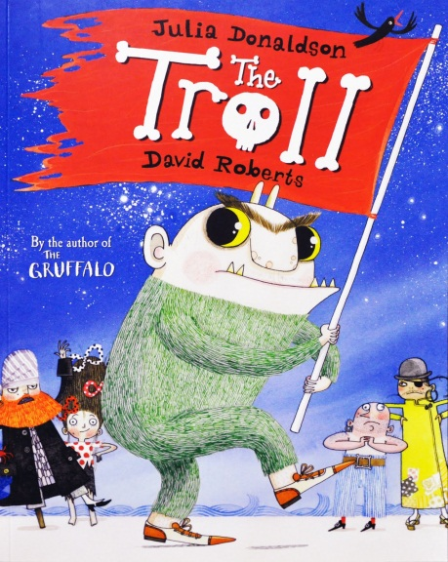
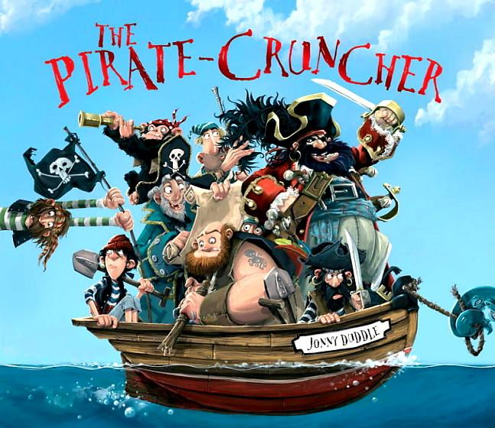
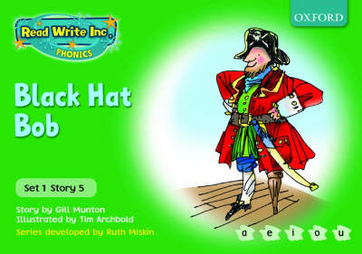

Green books | Suggested linked text
1. On the bus | Mr Magnolia- Quentin Blake  Green Eggs and Ham- Dr Seuss
2. My dog Ned | Hairy Maclary's Rumpus at the Vet- Lynley Dodd  Mog and the Vet- Judith Kerr
3. Six fish | Six Dinner Sid- Inga Moore  Flabby Tabby- Penny McKinlay and Britta Treckentrup
4. The spell | Room on the Broom- Julia Donaldson  Meg and Mog- Helen Nicoll and Jan Pienkowski  Spells- Emily Gravett
5. Black Hat Bob | The Pirate Cruncher- Jonny Duddle  The Troll- Julia Donaldson  Cat's Ahoy!- Peter Bentley and Jim Field  The Pirates Next Door- Jonny Duddle
6. Tug, tug | The Troll- Julia Donaldson  Port Side Pirates - Debbie Harter & Oscar Seaworthy
7. Chips | Handa’s Surprise- Eileen Browne
8. The web | The Very Busy Spider- Eric Carle  Aaaarrgghh, Spider!- Lydia Monks
9. Pip’s pizza | Come to Tea on Planet Zum-Zee- Tony Mitton  Here Come the Aliens- Colin McNaughton  We’re Off to Look for Aliens- Colin McNaughton
10. Stitch the witch | Winnie the Witch- Valerie Thomas  Badjelly the Witch- Spike Milligan  Meg and Mog- Helen Nicoll and Jan Pienkowski
Skateboard Sid | Demon Teddy- Nicholas Allan
Will’s net | We’re Going on a Bear Hunt- Michael Rosen & Helen Oxenbury

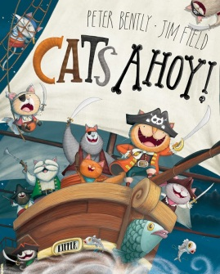

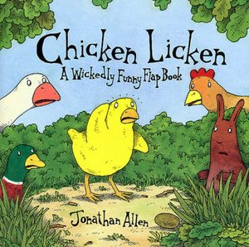
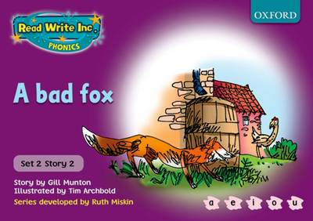

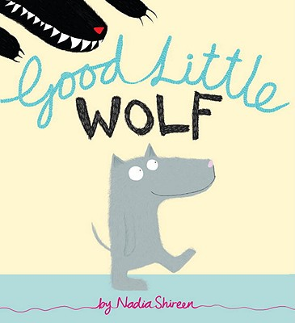
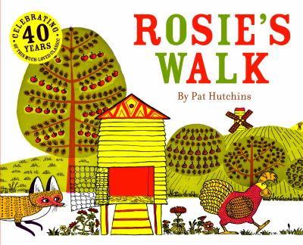

Purple books | Suggested linked text
1. Ken’s cap | Roadworks- Sally Sutton
2. A bad fox | Rosie’s Walk- Pat Hutchins  Chicken Licken- Jonathan Allen  Good Little Wolf- Nadia Shireen
3. Big Blob and Baby Blob | Baby Ruby Bawled- Malaika Rose Stanley  No, Baby, No- Grace Nichols  Please, Baby, Please- Spike Lee and Tonya Lewis Lee  Shopping with Dad- Matt Harvey
4. Tim and Tom | Stanley’s Stick- John Hegley  The Man whose Mother was a Pirate- Margaret Mahy  At the Beach- Roland Harvey  Seaside Poems- Nick Sharratt
5. Tag | Man on the Moon- Simon Bartram  We’re Off to Look for Aliens- Colin McNaughton  Beegu- Alexis Deacon
6. Elvis | The Smartest Giant in Town- Julia Donaldson  The Elves and the Shoemaker - Lucy M. George  The Elves and the Shoemaker- Alison Edgson
7. Flip Frog and the bug | Two Frogs- Christopher Wormell  Growing Frogs- Vivian French and Alison Bartlett
8. Red Ken | Dig, Dig, Digging- Margaret Mayo
9. Billy the Kid | The Troll- Julia Donaldson  The Three Billy Goats Gruff- Nick Sharratt  The Three Billy Goats Gruff- Ladybird books  The Goggle-Eyed Goats- Stephen Davies
10. In the bath | Five Minutes’ Peace- Jill Murphy  Mr Archimedes’ Bath- Pamela Allen
Tom’s tricks | Where the Wild Things Are-Maurice Sendak  Edwardo the Horriblest Boy in the Whole Wide World - John Burningham
Skateboard Sid and the hat | Willie the Wimp - Anthony Browne

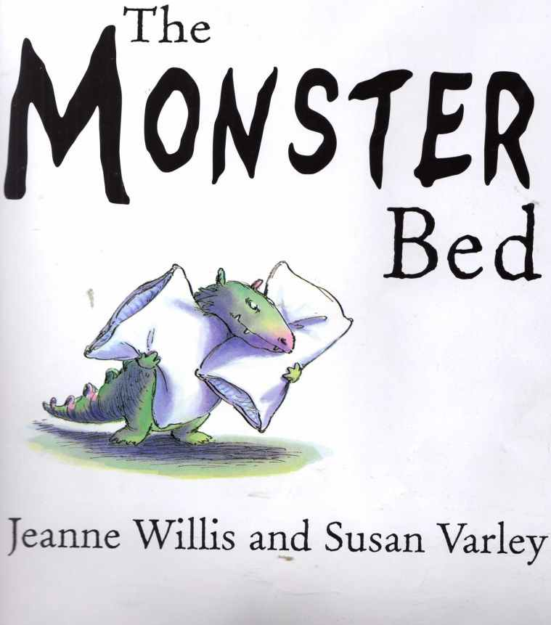
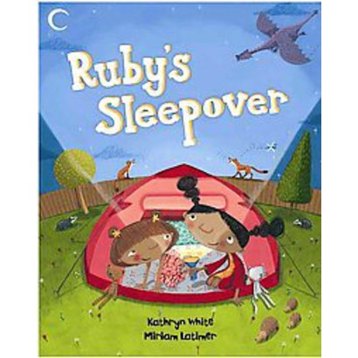
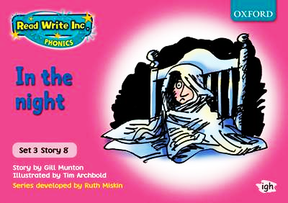

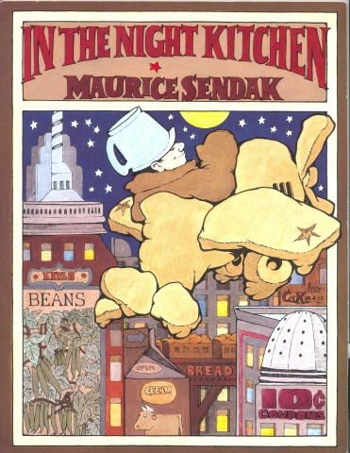

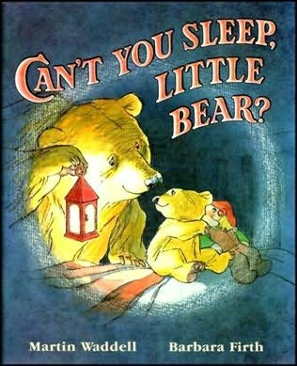

Pink books | Suggested linked text
1. Scruffy Ted | The Velveteen Rabbit - Margery Williams  Scruffy Bear and the Six White Mice- Chris Wormell  Second Best- Jane Eagland &Terry Milne  Nothing- Mick Inkpen  Dogger- Shirley Hughes
2. Tab the cat | I Want a Pet- Lauren Child  That Pesky Rat- Lauren Child  Six Dinner Sid - Inga Moore  Mog the Forgetful Cat - Judith Kerr  My Cat Jack - Patricia Casey
3. In the sun | Come Away from the Water Shirley- John Burningham.
4. The dressing up box | The Smartest Giant in Town- Julia Donaldson  Captain Flinn and the Pirate Dinosaurs- Giles Andeae and Russell Ayto
5. Tab’s kitten | Ginger- Charlotte Voake  Posy- Linda Newbery and Catherine Rayner  A Kitten Called Moonlight - Martin Waddell  Tabby McTat- Julia Donaldson and Alex Scheffler  Slinky Malinki- Lynley Dodd  Hairy Maclary’s Caterwaul Caper- Lynley Dodd
6. Sanjay stays in bed | Through My Window- Eileen Browne and Tony Bradman
7. The greedy green gremlin | Not Now Bernard- Brian McKee  Yuck! That’s not a Monster!- Angela McAllister  Morris the Mankiest Monster- Giles Andreae
8. In the night | Ruby’s Sleepover- Kathryn White  The Monster Bed- Jeanne Willis & Susan Varley  Can’t You Sleep, Little Bear?- Martin Waddell  In the Night Kitchen- Maurice Sendak
9. Snow | The Gruffalo’s Child- Julia Donaldson  The Snowman- Raymond Briggs
10. So cool! | Mrs. Armitage's Wheels - Quentin Blake
Bats | Bat Loves the Night - Nicola Davies
A map in the attic | The Treasure Hunt- A Tale from Percy’s Park- Nick Butterworth
The big match | Pass it, Polly - Sarah Garland  Willy the Champ- Anthony Browne  Wonder Goal- Michael Foreman

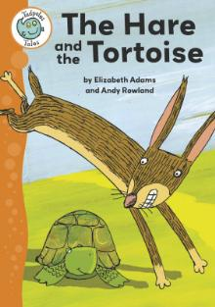
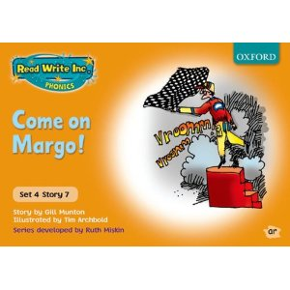

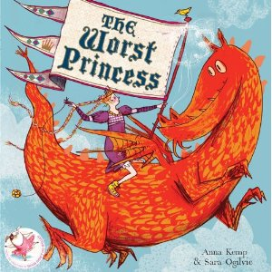
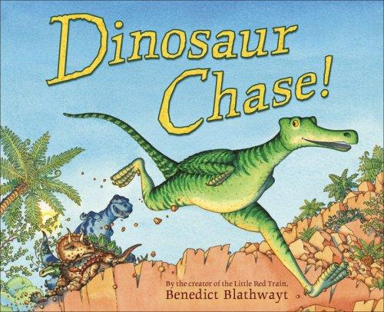

Orange books | Suggested linked text
1. Playday | Starting School- Janet Ahlberg  Alfie and the Big Boys- Shirley Hughes
2. I think I want to be a bee | Walking through the Jungle- Julie Lacome  The Animal Boogie- Debbie Harter  I Could Be, You Could Be- Karen Owen  The Beeman- Laurie Krebs
3. A bad fright | On the Way Home- Jill Murphy  A Dark, Dark Tale- Ruth Brown  Funnybones- Janet Ahlberg
4. Follow me! | The Ugly Duckling- Hans Christian Andersen and Bernadette Watts  Duck and Goose- Tad Hills
5. Too much! | The Cat in the Hat- Dr Seuss  Angry Arthur- Hiawyn Otam and Satoshi Kitamura  Everybody Feels Sad- Jane Bingham
6. A good cook? | Pumpkin Soup- Helen Cooper  The Giant Jam Sandwich- John Vernon Lord  The Tiger who came to Tea- Judith Kerr
7. Come on, Margo! | Dinosaur Chase- Benedict Blathwayt  The Worst Princess- Anna Kemp  The Tortoise and the Hare- Aesop’s Fables
8. My sort of horse | Dogs- Emily Gravett  The Artist who Painted a Blue Horse
9. Haircuts | Crazy Hair- Neil Gaiman and Dave McKean  I Love My Hair- Anastasia Tarpley  Bibbity Bop Barbershop- Anastasia Tarpley
10. My best shirt | Angry Arthur- Hiawyn Otam
11. Look out! | A New House for Mouse - Petr Horacek
12. Hunt the tortoise | Polly’s Puffin - Sarah Garland

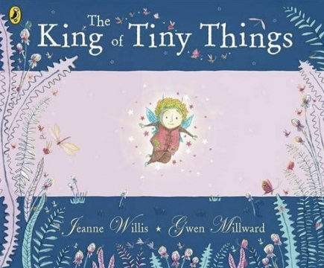
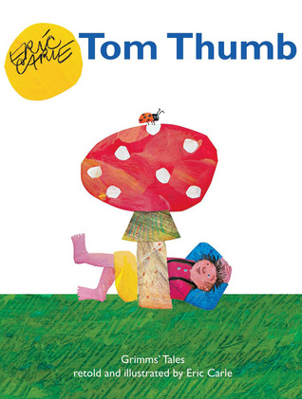
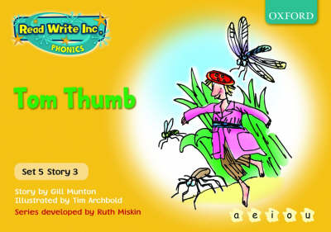

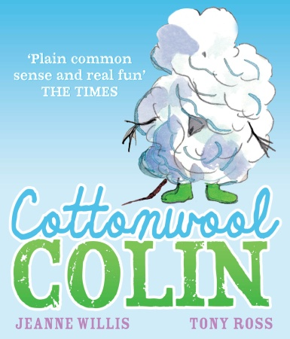

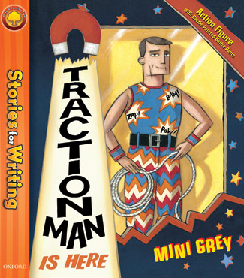

Yellow books | Suggested linked text
1. The duckchick | The Ugly Duckling- Hans Christian Andersen and Bernadette Watts
2. Offsick | Through My Window- Eileen Browne and Tony Bradman
3. Tom Thumb | The King of Tiny Things - Jeanne Willis & Gwen Millward  Traction Man - Mini Grey  Tom Thumb- Eric Carle  Cottonwool Colin- Jeanne Willis and Tony Ross
4. The gingerbread man | Jungle party- Brian Wildsmith  Biscuit Bear- Mini Grey  The Gingerbread Man- Estelle Corke
5. Robin Hood | Robin of Sherwood- Michael Morpurgo and Michael Foreman  Robin Hood- Rob Lloyd Jones
6. Lost | Lost and Found- Oliver Jeffers  Old Possum's Book of Practical Cats- T.S. Eliot and Axel Scheffler  Billy’s Beetle- Mick Inkpen  Dogger- Shirley Hughes
7. Do we have to keep it? | Sophie and the New Baby-Catherine Anholt  Mog and the Baby- Judith Kerr  The Trouble with Jack- Shirley Hughes  Rosie’s Babies- Martin Waddell  Owl Babies- Martin Waddell
8. Danny and the Bump-a-lump | Monstersaurus- Claire Freedman  Tappity-Tap! What was That?- Claire Freedman  The Dark, Dark Night- M Christina Butler
9. Grow your own radishes | Grandpa’s Garden- Stella Fry  George and Flora’s Secret Garden- Joanna Elizabeth Elworthy  Oliver’s Vegetables- Vivian French  Eddie’s Garden- Sarah Garland
10. The foolish witch | Into the Forest by Anthony Browne  Hansel and Gretel- Anthony Browne  Hansel and Gretel- Michael Morpurgo

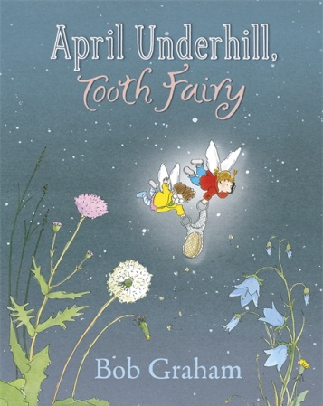
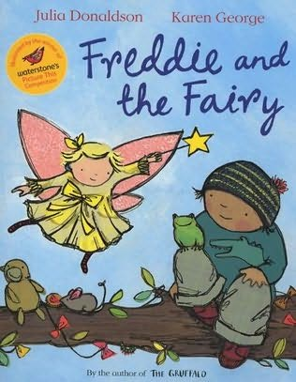
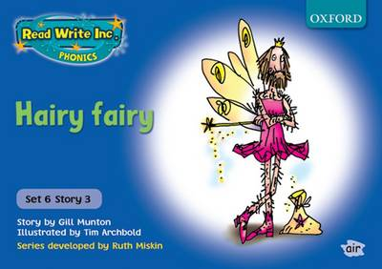

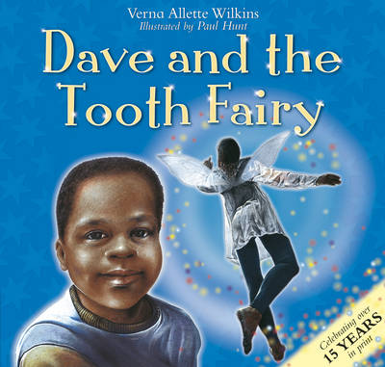
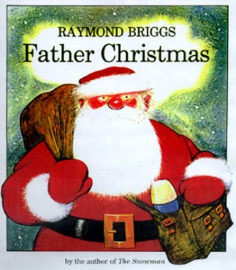

Blue books | Suggested linked text
1. Barker | Dogs - Emily Gravett  Dan and Diesel – Charlotte Hudson
2. The poor goose | The Hare and the Tortoise- Aesop’s fable
3. Hairy fairy | Dave and the Tooth Fairy- Verna Allette Wilkins  Freddy and the Fairy- Julia Donaldson  The Dolls’ House Fairy- Jane Ray  Father Christmas- Raymond Briggs  April Underhill, Tooth Fairy- Bob Graham
4. King of the birds | The Monkey with a Bright Blue Bottom- Steve Smallman  Sounds of the Wild Birds- Maurice Pledger  A Duck So Small – A H Benjamin
5. Our house | This is Our House- Michael Rosen  The Great Big Book of Families- Mary Hoffman
6. The jar of oil | The Rich Man and the Shoemaker- Brian Wildsmith
7. Jade’s party | The Trouble with Jack- Shirley Hughes  The Shopping Basket- John Burningham
8. Jellybean | Dear Zoo- Rod Campbell  I want a Pet- Lauren Child  Who wants to be a Poodle? I Don’t!- Lauren Child
9. A box full of light | The Owl who was Afraid of the Dark- Jill Tomlinson
10. The hole in the hill | The Pied Piper of Hamelin- Michael Morpurgo and Emma Chichester Clark

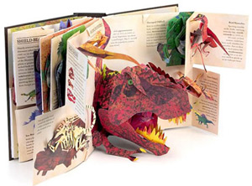
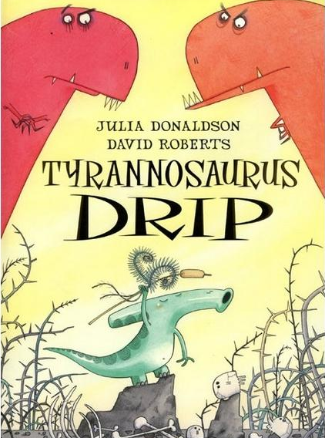
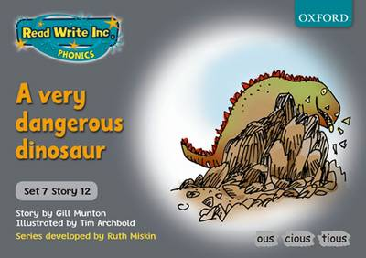

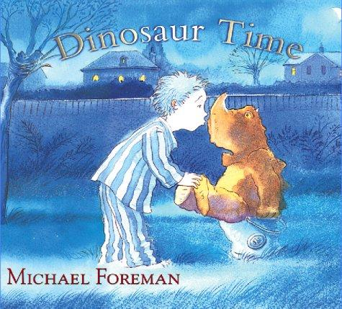

Grey books | Suggested linked text
1. Rex to the rescue | How Dogs Really Work- Alan Snow  Dan and Diesel – Charlotte Hudson
2. The lion’s paw | The Lion’s Paw - Gustaf Tenggren  Androcles and the Lion- Russell Punter (Adapter)  The Mouse and the Lion- Aesop’s fable
3. I dare you | Dr Xargle’s Book of Earthlets- Jeanne Willis and Tony Ross  The Cat in the Hat comes Back- Dr Suess  Don’t Put Your Finger in the Jelly Nelly- Nick Sharratt
4. Looking after a hamster | Little Beauty- Anthony Browne  Please, Puppy, Please- Spike Lee
5. How silly! | The Three Sillies- Tony Ross
6. Wailing Winny’s car boot sale | Winnie the Witch- Valerie Thomas
7. Toad | Tales of the Frog Princess - E. D Baker  The Princess and the Frog - Polly Perham
8. Andrew | Seal Surfer- Michael Foreman  A Boy and a Bear in a Boat- Dave Shelton  Lighthouse Keeper’s Rescue- David Armitage  Little Tim and the Brave Sea Captain- Edward Ardizzone  Captain Duck- Jez Alborough  Little Captain- Claudio Munoz  Mrs Armitage and the Great Big Wave- Quentin Blake
9. Dear Vampire | Dear Vampa- Ross Collins
10. Vulture culture | Eagles and Birds of Prey- Jemima Parry Jones  Amazing Birds of Prey- Jemima Parry Jones  The Sulky Vulture- Sally Grindley
11. A celebration on planet Zox | Man on the Moon- Simon Bartram
12. A very dangerous dinosaur | Dinosaur Time- Michael Foreman  Dinosaurs and All that Rubbish- Michael Foreman  Encyclopedia Prehistorica: Dinosaurs- Robert Sabuda and Matthew Reinhart  Tyrannosaurus Drip- Julia Donaldson  Dinosaur Chase- Benedict Blathwayt
13. The invisible clothes | The Emperor's New Clothes- Alison Edgson

Why use the RWI linked storybooks
We want children to love reading. Our best schools read linked real storybooks and select props to ensure that we:
- foster a love of stories and story language
- introduce key linked vocabulary that can be fed into the teaching of writing
- make links between previous real-life experience and/or other stories they have heard
- motivate children to want to read themselves
- provide a model of a storyteller's voice
- bring the books alive through hands on experience. The characters and places become real.

Where possible, children then borrow the linked story books and take home to share with an adult or siblings. Children take home the RWI books to read to someone independently. They re-read the RWI book with feeling and empathy because they have plunged into the story through the activities they have done with their teacher at school.

When to use the RWI linked storybooks
The linked books could be read to the children in a number of different ways before they read the RWI books.
Reading to an individual RWI group
Use the final part of the writing day (e.g. Day 3 or 5 of the timetable) to read the linked story book for the following new RWI text. For example, on Day 3 of teaching Purple book 1- Ken’s cap, finish the lesson by reading Chicken Licken by Jonathan Allen to the children. Tell the children that this is a story about a sneaky fox who craftily tricks the other animals. Make links to the book the children will read the next day- also about a sneaky fox. Use the power words from the RWI book (slink off, sneak away) in your discussion. The following day in the story introduction for A bad fox, refer to Chicken Licken; ‘We read this book yesterday and in the book you are going to read today, there is also a sneaky fox. I wonder what the crafty fox in this story does when he glances up and spots a hen in the yard ahead of him.’
If the books are being read as part of the RWI lesson it is important they don’t impede the rate of the children’s phonics progression. Keep the reading focused and make the links with purpose.
Reading to a whole class
Make sure the linked books become part of the texts you have in your class library to read to children in Reception and Year 1. Once children know these stories you can refer back to them in your story introduction
Assemblies
Some of the books can be used in assemblies to link the texts to central themes that occur in other storybooks and RWI books.

